Project Design Phase-II

**Data Flow Diagram & User Stories**

|  |  |
| --- | --- |
| Date | 10 Nov 2022 |
| Team ID | PNT2022TMID29189 |
| Project Name | Project - Real-Time Communication System Powered by AI for Specially Abled |
| Maximum Marks | 4 Marks |

**Data Flow Diagrams:**

A Data Flow Diagram (DFD) is a traditional visual representation of the information flows within a system. A neat and clear D FD can depict the right amount of the system requirement graphically. It shows how data enters and leaves the system, what changes the information, and where data is stored.

DFD:

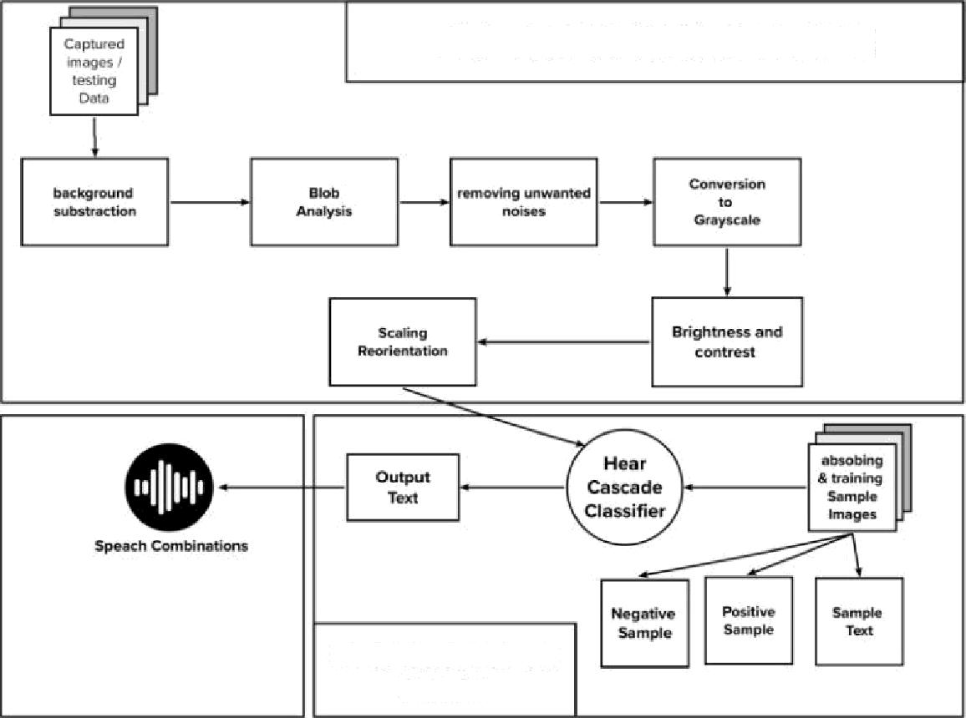

**PREPROCESSING STAGE**

**CLASSIFICATION**

STAGE

User Stories

Use the below template to list all the user stories for the product.

|  |  |  |  |  |  |  |
| --- | --- | --- | --- | --- | --- | --- |
| User Type | Functional Requirement  **(Epic)** | User Story Number | User Story / Task | **Acceptance criteria** | **Priority** | Release |
| Customer (Mobile user) | Registration | USN-1 | As a user, I can register for the application by entering my email, password, and confirming  my password. | I can access my account / dashboard | High | Sprint-1 |
|  |  | USN-2 | As a user, I will receive confirmation email once I have registered for the application | I can receive confirmation email & click confirm | High | Sprint-1 |
|  |  | USN-3 | As a user, I can register for the application through Facebook | I can register & access the  dashboard with Facebook Login | Low | Sprint-2 |
|  |  | USN-4 | As a user, I can register for the application through Gmail |  | Medium | Sprint-1 |
|  | Login | USN-5 | As a user, I can log into the application by entering email & password |  | High | Sprint-1 |
|  | Dashboard |  |  |  |  |  |
| Customer (Web user) | Registration | USN-1 | As a user, I can register for the application by entering my email, password, and confirming  my password. | I can access my account / dashboard | High | Sprint-1 |
|  |  | USN-2 | As a user, I will receive confirmation email once I have registered for the application | I can receive confirmation email & click confirm | High | Sprint-1 |
|  |  | USN-3 | As a user, I can register for the application through Facebook | I can register & access the dashboard with Facebook  Login | Low | Sprint-2 |
|  |  | USN-4 | As a user, I can register for the application through Gmail |  | Medium | Sprint-1 |
|  | Login | USN-5 | As a user, I can log into the application by entering email & password |  | High | Sprint-1 |
|  | Dashboard |  |  |  |  |  |

|  |  |  |  |  |  |  |
| --- | --- | --- | --- | --- | --- | --- |
| User Type | Functional  Requirement (Epic) | User Story Number | User Story / Task | Acceptance criteria | Priority | Release |
| Customer Care Executive | Resolving customer complaints brought to  attention | USN-1 | Lead and manage a team of agents, communicate customer needs to stakeholders, and understand exactly how customers use your product or service. | I can solve the customer complaints and keep it safe. | High |  |
| Administrator | Data access and modification . |  |  |  |  |  |
|  |  |  |  |  |  |  |
|  |  |  |  |  |  |  |
|  |  |  |  |  |  |  |
|  |  |  |  |  |  |  |
|  |  |  |  |  |  |  |
|  |  |  |  |  |  |  |
|  |  |  |  |  |  |  |
|  |  |  |  |  |  |  |
|  |  |  |  |  |  |  |
|  |  |  |  |  |  |  |
|  |  |  |  |  |  |  |